
DRAFT Greenhouse Gas Emissions Estimation and Reporting Guidelines for Agriculture, Fisheries and Forestry
Methodological Guidance
Chapter 1: General Guidance

© Commonwealth of Australia 2026
Ownership of intellectual property rights
Unless otherwise noted, copyright (and any other intellectual property rights) in this publication is owned by the Commonwealth of Australia (referred to as the Commonwealth).
Creative Commons licence
All material in this publication is licensed under a Creative Commons Attribution 4.0 International Licence except content supplied by third parties, logos and the Commonwealth Coat of Arms.
Inquiries about the licence and any use of this document should be submitted via our online contact form.

Cataloguing data
This publication (and any material sourced from it) should be attributed as: DCCEEW 2026, DRAFT Greenhouse Gas Emissions Estimation and Reporting Guidelines for Agriculture, Fisheries and Forestry - Methodological Guidance, Department of Climate Change, Energy, the Environment and Water, Canberra, March. CC BY 4.0.
This publication is available at dcceew.gov.au.
Department of Climate Change, Energy, the Environment and Water
GPO Box 3090 Canberra ACT 2601
Telephone 1800 920 528
Web dcceew.gov.au
Disclaimer
The Australian Government acting through the Department of Climate Change, Energy, the Environment and Water has exercised due care and skill in preparing and compiling the information and data in this publication. Notwithstanding, the Department of Climate Change, Energy, the Environment and Water, its employees and advisers disclaim all liability, including liability for negligence and for any loss, damage, injury, expense or cost incurred by any person as a result of accessing, using or relying on any of the information or data in this publication to the maximum extent permitted by law.
Acknowledgements
We thank Environmental Accounting Services for drafting this document, and the Voluntary Greenhouse Gas Estimation and Reporting Standards Reference Group for their valued contributions.
Acknowledgement of Country
We acknowledge the Traditional Owners of Country throughout Australia and recognise their continuing connection to land, waters and culture. We pay our respects to their Elders past and present.

Case Studies
Case Study 1a – Application of the Modules in a Mixed System | 11
Case Study 1b – Application of the Modules in a Production and Post-Production System | 13
Case Study 2a – Application of higher Method | 17
Case Study 2b – Application of higher Method | 18
Case Study 3a – Lime Application | 20
Case Study 3b – Lime Application | 21
Case Study 4a – Longer than 12-month production/lifecycles | 22
Case Study 4b – Longer than 12-month production/lifecycles | 23
Case Study 5 – Transferring manure between entities | 25
Case Study 6 – Selection of leaching, climate and rainfall cones in dryland system | 32
Case Study 7 – Herd Flow (minimum data option) | 34
Case Study 8 – Herd Flow (detailed data option) | 36
Case Study 9 – 18-month Herd Flow | 40
Case Study 10 – Herd Flow (Dairy Australia Data) | 42

General Guidance
Question Reference 1.1.
As you read the Methodological Guidance, please consider the following questions.
Will the content support you or other users to collect the appropriate data and undertake emissions estimates?
Could the content be presented in alternative ways to make it more accessible?
Is there fundamental content missing? If so, please outline your suggestions for other material that may be useful.

Introduction
Understanding the greenhouse gas (GHG) emissions profile of a business is becoming increasingly important for agriculture, fisheries and forestry (AFF) industries. Demand for emissions data is expected to increase, driven by a range of factors including evolving market expectations, and supply chains and financial institutions seeking to monitor progress against voluntary climate commitments. Additionally, some large AFF entities may be required to report under Australia’s mandatory climate-related financial disclosures regime, as set out in the Corporations Act 2001.
The Australian Government has developed the voluntary GHG Emissions Estimation and Reporting Guidelines for Agriculture, Fisheries and Forestry (the Guidelines) to provide a nationally consistent framework and methods for estimating and reporting GHG emissions and removals from AFF entities.
The Guidelines comprise complementary documents (see Figure 1.1):
- The Common Requirements Framework which provides requirements for, and high-level guidance on establishing boundaries, selecting calculation approaches to estimate GHG emissions and removals, product emissions intensity, assessing data quality and reporting.
- Emissions Methodological Guidance (this document) which provides the specific equations, data sources, and calculation protocols needed to estimate emissions in a consistent and verifiable way.
- Land Use, Land Use Change and Forestry (LULUCF) Methodological Guidance which provides specific guidance and instructions needed to estimate emissions and removals from LULUCF activities in a consistent and verifiable way.
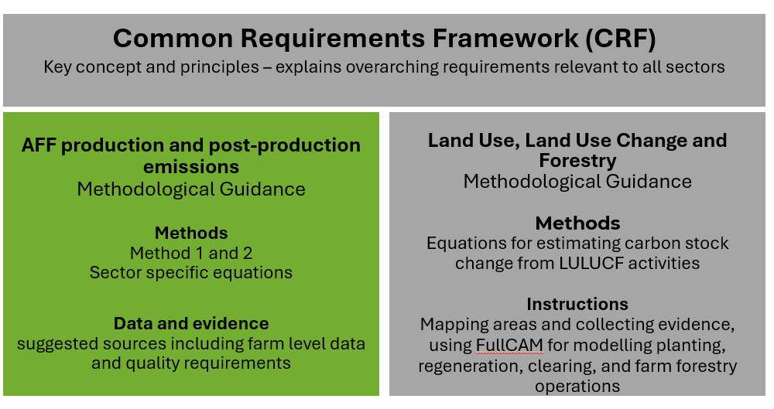
Figure 1.1: The relationship of this Guidance to other documents in the Guidelines.
For further guidance on how to apply the Guidelines, the intended users of the Guidelines and the coverage and limitations of the Guidelines, including product emissions intensity, refer to Section 2 of the Common Requirements Framework (CRF).

Purpose of the Methodological Guidance
The Methodological Guidance (the Guidance) supports consistent, transparent, and practical estimation and reporting of annual GHG emissions.
Its purpose is to:
- provide methods that are scientifically robust and appropriate for Australian production systems and environments
- reduce variability in reported emissions and removals across GHG calculators
- increase the confidence of producers, advisors, and decision-makers in GHG emissions and removals data.
The Guidance has been designed to:
- align with the Australian National Greenhouse Accounts (NGA) which are used to estimate and track Australia's greenhouse gas emissions. Estimation methods have been adapted for use at the entity level
- build on existing best-practice tools such as the Agriculture Innovation Australia (AIA) Common Accounting Framework Methods and Data Guidance
- align with relevant international standards (e.g. ISO 14064-1:2018, GHG Protocol Corporate and Value Chain (Scope 3) Standards, as well as the Scope 3 Calculation Guidance where practical
- provide a choice of methods so that entities may achieve reliable and consistent estimates aligned with available data and the goals of their inventory.
Through the consistent application of the Guidance, Australian producers will be better positioned to inform emissions reduction strategies and meet GHG reporting requests and requirements.

Coverage and limitations of the Guidance
Tranche 2 of the Guidance outlines methods for estimation of entity Scope 1 emissions sources associated with Poultry, Pigs, Horticulture, Viticulture, Aquaculture and Wild Fisheries, and Other Livestock (Buffalo, Goats, Deer, Camels, Alpacas, Horses, Mules/asses and Emus/ostriches) activities. It also includes methods for estimation of Scope 2 emissions, and a subset of possible Scope 3 emissions. The consultation questions throughout the Guidance focus on Tranche 2 estimation methods. However, we welcome feedback on all of the Guidance.
The agriculture sector methods in the NGA are being updated. The methods provided in the Guidance reflect the most up to date information on the proposed changes and may be revised before publication
The Guidance provides methods for estimating annual Scope 1, 2 and Scope 3 emissions and removals relevant to the following AFF production activities:
- Livestock (beef, dairy, sheep, poultry, pigs and other livestock categories)
- Cropping (grains, legumes, sugar, rice, cotton)
- Horticulture
- Viticulture
- Aquaculture and wild catch fisheries
- Land Use, Land Use Change and Forestry (LULUCF).
This Guidance is primarily designed for:
- tool developers creating or updating GHG emissions calculators
- GHG accountants and consultants working with clients to develop farm level GHG inventories
- producers who are actively engaged or interested in understanding emissions estimation methods and data collection prioritisation
- advisors, extension officers, and sustainability managers involved in or supporting emissions reporting.
Producers will be able to estimate their entity’s emissions using a GHG calculator aligned with the Guidelines. They do not need to understand the technical details of the methods in these documents unless they are interested to understand the scientific basis of estimation.
The Guidance focuses on quantifying emissions from cradle-to-gate activities. The term ‘gate’ refers to the point immediately after primary production—such as the ‘farm-gate’, ‘point of harvesting’ or ‘point of landing’. As such, methods for Scope 3 categories are directed at upstream emissions.
Currently, the Guidance does not provide methods for the upstream Scope 3 categories of capital goods, business travel, employee commuting, and non-land leased assets. Entities should determine whether these categories are relevant and material to their inventory. Where applicable, emissions may be estimated using emission factors from national and international databases to estimate these emissions if required (e.g. Australian Life Cycle Inventory Database, Ecoinvent). For further details on boundary setting and materiality, refer to CRF, Section 5.
A generic Post-Production Module is provided in Chapter 2 Section 2.13 for entities that undertake value-added processing within their operations (e.g. producing wine from grapes, timber milling or cooking prawns) or wish to apply a cradle-to-first-point-of-sale boundary. This module covers the estimation of emissions occurring after the ‘gate’, including those from transportation, storage, processing and packaging.
This document does not explain the scientific basis of specific emissions sources and sinks, nor does it repeat foundational inventory design principles or rules outlined in the CRF. However, cross-references are provided to ensure clarity and coherence.

Using the Guidance
The Guidance adopts a modular approach to support ease of use and flexibility. Estimation Modules are structured around specific emission sources and estimation methods, enabling consistent and comprehensive annual emissions reporting. This modular structure allows entities to tailor emissions estimation to their specific reporting boundaries, including mixed production systems, while considering estimation objectives and data availability.
Entities should apply the Guidance using the following stepwise approach:
Step 1. Define organisational and reporting boundaries
Refer to Section 5 of the CRF for guidance on establishing boundaries. These boundaries determine which emissions sources and sinks shall be included in the inventory.
Step 2. Identify emissions sources within the reporting boundary (Chapter 2)
Based on the defined reporting boundary and production activities, identify the emissions sources which need to be considered and the relevant estimation Modules.
Step 3. Select estimation approach aligned with data availability and inventory goal (Chapters 3-15)
For each identified Module, select the estimation approach that best fits the available data and the intended use of the inventory.
Step 4: Collect required data and calculate GHG emissions and removals
Each Module includes:
- Step-by-step estimation methods
- Guidance on data requirements and data quality considerations.
Step 5: Ensure transparency and traceability
As Modules are applied, it is good practice to document all assumptions, data sources, estimation parameters, and methodological decisions to support transparency.
Case Study 1a and Case Study 1b give examples of how to apply the Guidance, including how Modules may be mapped to a mixed enterprise system or how the post-production module can be integrated with sector specific modules.

Use of terminology in this document
While use of the Guidelines is voluntary, the Guidance specify requirements that need to be followed to claim compliance with the Guidelines. The following terminology is used:
- ‘Shall’ indicates what is necessary to meet the minimum requirements of these Guidelines
- ‘Should’ indicates a recommendation
- ‘May’ indicates an optional aspect.

Methods for Estimation
GHG emissions or removals may be estimated in different ways, ranging from simple methods using emission factors or empirical relationships to process-based models and field measurements using highly specialised equipment. The Guidance allows entities to select the calculation method that best aligns with the desired levels of accuracy and data availability.
Calculation methods have been classified according to three Method levels. In general, moving to the higher-level methods improves the accuracy of the estimates and reduces uncertainty. However, the increased complexity and additional data requirements can increase costs and resourcing requirements.
- Method 1 provides the minimum requirement for estimation. It generally applies the emissions factors or empirical relationships from the NGA and requires core site-specific activity data (e.g. head of livestock, tonnes of fertiliser applied). National or regional default values from the NGA are provided for other input parameters
- Method 2 is more complex, usually applying the same methodological approach as Method 1 (i.e. the same equations), but requires additional site-specific data. It also includes use of the NGA process-based model FullCAM and the FullCAM-derived SAVCAM tool for LULUCF activities.
- Method 3 is most demanding in terms of complexity and data requirements. Method 3 approaches use higher order estimation methods, including sophisticated process-based models (other than FullCAM or SAVCAM) and detailed measurement systems tailored to specific systems, often repeated over time, and driven by high-resolution activity data. The Guidance does not currently provide Method 3 calculation approaches.
The entity should select and use the calculation method(s) that best align with available data and the entity’s goal for compiling the GHG inventory. The entity may select different method levels for different sources and sinks. Some sources and sinks may have only one method option available in the Guidance. Refer to Section 1.6.1 and Figure 1.2 for guidance on decision making for data collection.
It is recommended that Method 2 is adopted where suitable data exists. Method 2 should be considered where mitigation actions or improved management practices are being adopted or verification is needed. When applying Method 2, it is essential to use credible and verifiable sources of entity-specific data. Guidance on data quality requirements for input data sources is provided in relevant Modules in Chapters 3 – 15.
The entity shall document the methods applied and any changes in methods since its previous report as per the Reporting requirements set out in Section 9 of the CRF.
Table 1.1: Characteristics of data and resulting estimates
Consideration | Method 1 | Method 2
Data Source | Some producer level data, but high reliance on default data | High reliance on producer specific data
Accuracy | Low to Moderate | Higher (if properly implemented)
Resource Requirement | Low | Moderate to high
Uncertainty | Higher | Lower (if properly implemented)

Case Study 1a – Application of the Modules in a Mixed System
Entity Description
Silver Meadows Station is a 1500 ha property in Western Victoria owned and operated by Fiona and her sister Lauren. In total they have 1050 ha of the property under grazing which consists of a flock of 1000 Merino sheep and 200 head of beef cattle for sale to a nearby feedlot for finishing. They also offer agistment to their neighbour, Richard, with 50 ha allocated to 20 head of beef.
In good years they grow winter crops including wheat, oats and barley on 300 ha. Their parents planted sugar gum managed for wood production throughout the property, totalling 100 ha over a 5-year period, 20-25 years ago. Fiona and Lauren have been asked to develop a GHG estimate for their bank as they are wanting to incorporate producer-specific data into their reporting of financed emissions.
Identifying the Modules
Fiona and Lauren’s mixed enterprise needs to consider emissions estimation Modules related to pasture-based beef, sheep, and cropping. Sequestration by the sugar gum plantations is covered by the Land Use, Land Use Change and Forestry Module. The relevant emissions Modules and sections (see Chapter 2: Implementation Guides) required are outlined below.
Module | Reporting Category | Estimation Module
Enteric fermentation | Scope 1 | 3.2 and 3.4
Manure management | Scope 1 | 4.2 and 4.4
Fertiliser use | Scope 1 | 5.1 – 5.5
Agriculture residue management | Scope 1 | 6.2 – 6.3
Transport and stationary fuel | Scope 1 | 8.1 – 8.2
Solid waste treatment | Scope 1 | 10.1
Purchased electricity | Scope 2 | 14.1
Upstream emissions from fuel | Scope 3 | 15.11
Purchased electricity (upstream) | Scope 3 | 15.12
Purchased livestock | Scope 3 | 15.1
Purchased feed and mineral supplements | Scope 3 | 15.2 – 15.3
Purchased fertiliser | Scope 3 | 15.4
Purchased agrichemicals | Scope 3 | 15.5
Purchased lime | Scope 3 | 15.6
Management of waste | Scope 3 | 15.13
Purchased services/contractors | Scope 3 | 15.7
Other purchased goods and services | Scope 3 | 15.10
Recording herd movements on Silver Meadows Station is relevant to both cattle owned by Fiona and Lauren and those owned by their neighbour Richard that are on agistment.
If Fiona and Lauren have operational control of the agisted animal (that is, if they are responsible for animal management and performance), they would report enteric fermentation and manure emissions from the agisted stock as their Scope 1 emissions, and Richard would report it as part of his Scope 3 emissions. However, if Richard maintains control of the 20 head of cattle, then the responsibilities for Scope 1 and 3 reporting would be reversed. See Appendix C of the CRF for more information.

Case Study 1b – Application of the Modules in a Production and Post-Production System
Entity Description
Greenbank Horticulture is a 150 ha commercial vegetable and berry operation located in the Lockyer Valley in Queensland. The business produces leafy greens, cabbage, broccoli and strawberries for both domestic retailers and export markets. Greenbank has been asked by its primary retail buyers to develop a farm-level GHG inventory as they are wanting to incorporate producer specific data into their reporting of emissions.
Identifying the Modules
Greenbank Horticulture shall consider which Modules apply to the production system and post-production of their vegetable and strawberry products. Greenbank owns and operates a factory 20 km from the farming platform, which processes and packages their leafy green salads and strawberries for retail domestic and export markets. Greenbank’s cabbage and broccoli is sold post-production, without further processing, direct to international retailer.
The relevant emissions Modules and sections (see Chapter 2: Implementation Guides), for Greenbank’s horticultural crops within the production system, to the point of harvest*, are outlined below:
Module | Reporting Category | Estimation Module
Fertiliser use | Scope 1 | 5.1 – 5.5
Agriculture residue management | Scope 1 | 6.1, 6.3, 6.4
Transport and stationary fuel | Scope 1 | 8.1 – 8.2
Solid waste treatment | Scope 1 | 10.1
Purchased electricity | Scope 2 | 14.1
Purchased fertiliser | Scope 3 | 15.4
Purchased herbicides/pesticides | Scope 3 | 15.5
Purchased lime | Scope 3 | 15.6
Purchased services/contractors | Scope 3 | 15.7
Purchased packaging | Scope 3 | 15.8
Purchased grow media | Scope 3 | 15.9
Other purchased goods and services | Scope 3 | 15.10
Upstream emission from fuel | Scope 3 | 15.11
Purchased electricity (upstream) | Scope 3 | 15.12
Management of waste | Scope 3 | 15.13
*Greenbank uses Section 5 of the CRF to help set boundary specific to the business.
Greenbank wants to include the emissions from their post-production activities in their GHG inventory. The company gathers data associated with activities which occur after the point of harvesting for their leafy green salads and strawberries as they control these post-production facilities. The relevant Modules and sections for the quantification of these post-production emissions are outlined below.

Module | Reporting Category | Estimation Module
Transport and stationary fuel | Scope 1 | 8.1 – 8.2
Refrigerant use | Scope 1 | 9.1
Solid waste treatment | Scope 1 | 10.1
Wastewater treatment | Scope 1 | 12.1
Purchased electricity | Scope 2 | 14.1
Purchased packaging | Scope 3 | 15.8
Other purchased goods and services | Scope 3 | 15.10
Upstream emission from fuel | Scope 3 | 15.11
Purchased electricity (upstream) | Scope 3 | 15.12
Management of waste | Scope 3 | 15.13
Upstream freight | Scope 3 | 15.14
If Greenbank wants to include post-production activities from their cabbage and broccoli crops to reflect emissions to the consumer, they will need to set their downstream boundary, source activity data and emissions factors to quantify the emissions associated with downstream packaging, downstream freight, downstream refrigeration, and any other relevant downstream Scope 3 emission activities.
Assessing their emissions from cradle-to-point-of-harvest for all crops allows Greenback to calculate a product emissions intensity figure for their crop production to this point (Sections 2 and 10 of the CRF for more details on emissions intensity). This metric allows Greenbank to compare the efficiency of their crop production to harvest over time. Greenbank chooses to estimate their electricity, fuel, or other emission sources separately between production and post-production. Other entities may choose to estimate their emissions from cradle-to-distribution-gate without distinguishing emissions between production and post-production.
Some of the estimation modules within this guidance for calculating upstream Scope 3 emissions may also be utilised to calculate downstream Scope 3 emissions such as 5.11 and 5.12 but this guidance does not extend to the full boundary of all downstream Scope 3 emissions. It is recommended Greenbank assess the materiality of the Scope 3 downstream emissions to consider the importance of estimating and reporting these emissions. See the Common Requirements Framework for more information of assessing the materiality of emissions sources.
See Chapter 2, Section 2.13 for additional information on Modules and data checklists relevant to the development a GHG inventory for post-production.

Method selection and data collection decisions
Moving from Method 1 to Method 2 may be driven be a range of strategic and operational reasons including:
- Improved accuracy and decision-making: While Method 1 is designed for simplicity and comparability it can lack precision. Method 2 provides more specific and representative estimates, better reflecting practices, production outcomes, technologies, and emissions more accurately.
- Compliance and reporting requirements: Certain voluntary or regulatory reporting schemes and frameworks may require more detailed and granular estimates.
- Risk management and corporate responsibility: More accurate and representative data can help identify and provide insight into how to mitigate risks associated with significant sources of emissions. Method 2 data can enable more strategic GHG mitigation planning.
It is not always possible to collect high quality data for all sources and sinks that need to be included in an inventory. For this reason, data collection efforts should be prioritised. Entities should prioritise data collection efforts for key sources and sinks (those expected to result in higher emissions or removals, or those showing largest change over time) and for parameters that have the greatest influence of emissions (e.g. animal numbers and liveweight gain, or crop production). When uncertainty in data collected for Method 2 estimation exceeds the potential improvements from increased granularity it may be more appropriate to use Method 1 approaches while data collection processes are improved.
Box 1 presents a conceptual decision tree to help guide Method adoption. Case Study 2a and 2b provide examples of different enterprises prioritising different Method 2 approaches based on data availability, materiality of emissions sources, and reporting needs.

Figure 1.2 – Decision making for data collection
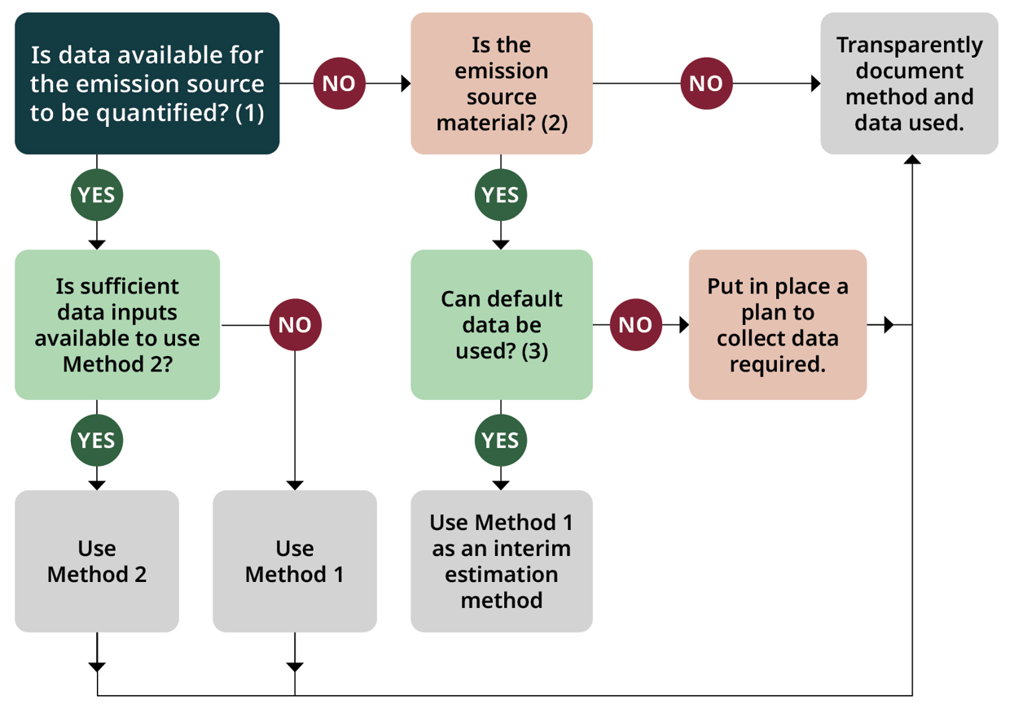Figure 1.2: Decision making for Method 2 data collection
Question 1: Is data available for the emission source to be quantified? Availability of data refers to both data quality considerations (e.g. is there confidence in the data) and time series consistency (e.g. will there be access to the same level of data in subsequent reporting periods). Reliable data sources are needed to have confidence in the estimation of annual emissions and to enable comparison between years.
Question 2: Is the emission source material? Materiality may be an important consideration in decision making related to prioritising resources (e.g. time and money) for data collection. Available resources should be prioritised for data used in Method 2 defined in the relevant Modules of the Guidance. Refer to the CRF, Section 5.2 for additional guidance on determining materiality.
Question 3: Can default data be used? For emissions sources that are material (significant to the overall inventory) default data should be used over excluding an estimate from the inventory. Data sources may be improved overtime to enable movement from Method 1 to Method 2. Developing estimates with the best available data and Method can provide useful insights for decision making as an alternative to exclusion of the emissions source from quantification.
Case Study 2a – Application of higher Methods
Entity Description
Redridge Herefords is a 2000 ha mixed enterprise in Southern New South Wales. Joe runs 300 cows for prime beef production and pedigree breeding production. The breeding herd is pasture-based and they finish all animals using a feedlot system. Around 600 ha of the property is used for production of canola, wheat, and barley on a rotational cropping system, with a proportion of the yield being kept for feeding and the rest being sold.
Redridge Herefords supplies beef animals to the processor NSW Prime Beef, which has offered all producers a bonus if they use specific activity data for scope 1 and 2 estimates. Joe keeps good records on his activities and operations, so he is going to transition to producer-specific Method 2 approaches for his annual GHG inventory.
Identifying the Modules requiring higher methodological approaches.
Joe needs to consider a number of emissions estimation Modules related to beef and cropping. The Method 2 estimation Modules to be adopted by Redridge Herefords are defined below.
Module | Method Required | Higher Methodological Requirement
Enteric fermentation | Method 2 | Required to use Method 2 equations and with herd-specific numbers, stay length within finishing system, feed intake and quality information, and production data.
Manure management | Method 2 | Required to use Method 2 equations with manure systems proportions, feed intake and quality information, and liveweight gain.
Fertiliser use | Method 2 | Required to use Method 2 equations with application records and fertiliser type, including manure and lime applied to soils and rate of application.
Agriculture residue management | Method 2 | Required to use Method 2 equations with crop production data.

As there is only one method for Transport and Stationary Fuel, Joe adopts Method 1 to estimate these emissions.
As Joe has not purchased any renewable electricity, he uses the Location-based method to estimate his Scope 2 emissions from Purchased Electricity.
Redridge Herefords’ neighbour, Bob, operates a nearby 1,000 ha sheep breeding enterprise. While he is not yet subject to the same reporting requests, he is aware of the shifting industry requirements and after talking with Joe he voluntarily adopts Method 2 estimation for his annual GHG inventory. During the year, Bob was able to improve the accuracy of his data relating to herd performance, feed efficiency and fertiliser application to move to Method 2 calculations. He found having more accurate data not only improved his GHG estimates, it also highlighted opportunities to improve lambing rates, feed efficiency and animal growth rates within his operation.
For both Redridge Herefords and their neighbour, a focus on data collection provided value in both sustainability reporting and management decision-making.
Case Study 2b – Application of higher Methods
Entity Description
Westland Poultry Farm is a 60,000 free range layer operation in Northern Victoria. Jane manages the layer operation and on-site egg packing facility.
Westland Poultry Farm supplies eggs to a national processor, who offer participating farms a bonus if they provide producer-specific activity data for their Scope 1 and Scope 2 emissions. Jane maintains detailed records on feed consumption, energy use, manure management and egg production rates. As a result, she is transitioning to producer-specific Method 2 approaches for her annual GHG inventory.
Identifying the Modules requiring higher methodological approaches.
Jane needs to consider a number of emissions estimation Modules related to poultry. The Method 2 estimation Modules to be adopted by Westland Poultry Farm are defined below.
Module | Method Required | Higher Methodological Requirement
Manure management | Method 2 | Required to use Method 2 equations with feed intake and quality information.

Method 2 options for fertiliser use and agricultural residual management are not applicable to poultry farms, so these are not used. There is only one method for solid waste management, refrigerant use, transport and stationary fuel, so Jane adopts Method 1 to estimate these emissions.
As Jane has not purchased any renewable electricity, she uses the Location-based method to estimate her Scope 2 emissions from purchased electricity.
Westland Poultry Farm’s neighbour, John, operates a nearby swine enterprise. While he is not yet subject to the same reporting requests, he is aware of the shifting industry requirements and after talking with Jane he voluntarily adopts Method 2 estimation for his annual GHG inventory. During the year, John was able to improve the accuracy of his data relating to feed consumption, manure management and energy use to move to Method 2 calculations. He found having more accurate data not only improved his GHG estimates, it also highlighted opportunities to improve his herd performance and manure handling practices within his operation.
For both Westland Poultry Farm and their neighbour, a focus on data collection provided value in both sustainability reporting and management decision-making.

Calculating annual GHG emissions and removals
Entities shall estimate and report emissions and removals for the year in which the emissions or removal activity occurs (e.g. year of fertiliser application or land preparation). That is, management inputs shall not be allocated across multiple years.
Box 2, and Case Studies 3a and 3b provide examples of how this operates for occasional land management activities that may follow multi-year cycles. Case Studies 4a and 4b provide examples of how this operates where production cycles are longer the 12 months.
Entities shall estimate and report emissions within the set boundary of control as outlined in Section 5 of the CRF. Case Study 5 provides an example of how the Guidance is applied in cases where emissions sources are passed between entity boundaries during the annual report period.
Box 1: Occasional Emissions Activities
Occasional emissions activities are any GHG emitting practice in agriculture or land management that:
- does not occur every year
- produces emissions (e.g. CO₂, CH₄, N₂O) when it does occur
- is linked to regular land management or production cycles.

Examples of occasional emissions activities
Activity | Typical Frequency | Emissions Type
Lime application (to reduce soil acidity) | Every 2–5 years | CO₂ from carbonate dissolution
Infrequent manure spreading from stockpiled waste | Irregular | N₂O from agricultural soils
Pasture renovation | Irregular | N₂O from agricultural soils

Although some agricultural practices (like liming, manure application, or fertiliser use) may follow multi-year cycles, emissions from these practices shall not be allocated across the cycle.
In practice, this requires:
- tracking the actual timing of occasional activities (e.g. liming events)
- inclusion of zero emissions for years in which the activity does not occur.

Case Study 3a - Lime Application
Entity Description
Dawnbank is a 3000 ha cropping and sheep entity located just outside of Tardun, Western Australia. Dawnbank is managed by Eamon and his family, who manage a flock of 500 merino sheep with 2000 ha of arable cropping. The sheep flock is a pasture-based system, and the arable enterprise focuses on production of wheat, canola and lupins.
Agricultural lime is applied at intervals of four years across both the arable and pasture areas to manage soil acidity. Dawnbank is required to prepare an annual GHG inventory under their bank’s sustainability-linked lending arrangement.
Identifying the emission profile
Eamon needs to consider a number of emissions estimation Modules related to sheep and cropping to develop his annual emissions as defined below.
Module | Reporting Category | Description
Enteric fermentation | Scope 1 | Emissions from sheep
Manure management | Scope 1 | Emissions from manure voided to pasture
Fertiliser use | Scope 1 | Application of fertilizer, lime and emissions from manure voided to pasture
Crop residues | Scope 1 | Residue breakdown from arable crops
Fuel use | Scope 1 | Emissions from machinery and irrigation
Purchased electricity | Scope 2 | Emissions from Dawnbank operation
Various scope 3 Modules | Scope 3 | Purchases and management for Dawnbank operation

The occasional application of lime causes an 8% spike in Dawnbank’s emissions in the year of application. Eamon wonders if he can spread the GHG impact of liming across the 3 years between application to smooth the emissions across the time period.
However, the bank requires the annual GHG inventory for their total annual financed emissions. Therefore, emissions shall be reported in the year that the emissions activity occurs, and not evenly spread across the intervening four years between lime applications. It is also important to consider that the bank focused on their portfolio of financed annual emissions rather than one producer’s data in isolation.
If Eamon wants to create a base period for comparison of changes in emissions over time, he may average over a period of 4 years to prevent this single year spike from impacting this assessment. More guidance on tracking emission over time is provided in Section 7 of the CRF.
Case Study 3b - Lime Application
Entity Description
Glenlorn Equine Farm is a 200 ha mixed equine breeding and sporting entity located in the Southern Highlands in New South Wales. Glenlorn is managed by Marlee and her family, who manages 100 horses and produces their own hay and haylage feed.
Agricultural lime is applied at intervals between three-five years across both the pasture areas and the cropping paddocks for haylage production to manage soil acidity. Glenlorn is required to prepare an annual GHG inventory under their bank’s sustainability-linked lending arrangement.
Identifying the emission profile
Marlee needs to consider a number of emissions estimation Modules related to equine and cropping to develop her annual emissions as defined below.
Module | Reporting Category | Description
Enteric fermentation | Scope 1 | Emissions from horses (other livestock)
Manure management | Scope 1 | Emissions from manure voided to pasture (other livestock)
Fertiliser use | Scope 1 | Application of fertilizer, lime and emissions from manure voided to pasture
Crop residues | Scope 1 | Residue breakdown from pasture crops
Fuel use | Scope 1 | Emissions from machinery and irrigation
Purchased electricity | Scope 2 | Emissions from Glenlorn operation
Various scope 3 Modules | Scope 3 | Purchases and management for Glenlorn operation

The occasional application of lime causes an 8% spike in Glenlorns emissions in the year of application. Marlee wonders if she can spread the GHG impact of liming across the three-five years between application to smooth the emissions across the time period.
However, the bank requires the GHG inventory for their total annual financed emissions. Therefore, emissions shall be reported in the year the emissions activity occurs, and not evenly spread across the intervening 3 years between lime applications.
It is also important to consider that the bank is not interested in one producers’ data in isolation, but rather is focused on their portfolio of financed annual emissions.

Case Study 4a - Longer than 12-month production/lifecycles
Entity Description
Rivercut Farm is a 1200 ha sugar cane producer located in Northern Queensland. The producer operates under a continuous ratoon cycle. The average sugar cane crop cycle is typically one plant crop followed by 3-4 ratoon years each of 12-24 months duration.
Rivercut Farm sells their sugar cane to a local brewed drinks company; the brewing company requires the producer to produce an annual GHG inventory. Although the production life cycle of sugar cane extends beyond 12 months, Mike shall produce an annual GHG inventory report that ensures emissions are reported in the year the activity takes place.
Identifying the impact of extended production or lifecycles
Mike needs to consider a number of emissions estimation Modules related to cropping. The impact of longer production or lifecycles for relevant emissions Modules to be adopted by Rivercut Farm are defined below.
Module | Reporting Category | Description
Fertiliser use | Scope 1 | Various applications depending on growth stage
Soil management | Scope 1 | Lime application once every five years
Crop residues | Scope 1 | Residue breakdown from sugar cane harvest
Fuel use | Scope 1 | Influenced by production stage requirements
Purchased electricity | Scope 2 | Rivercut Farm operation
Various scope 3 Modules | Scope 3 | Purchases and management practices for Rivercut Farm operation

Rivercut Farms annual GHG inventory doesn’t mirror other arable crops due to certain practices (e.g. land preparation, planting and harvesting) occurring non-annually. Despite the multi-year crop cycle, Mike ensures the GHG inventory aligns with the 12-month reporting window.
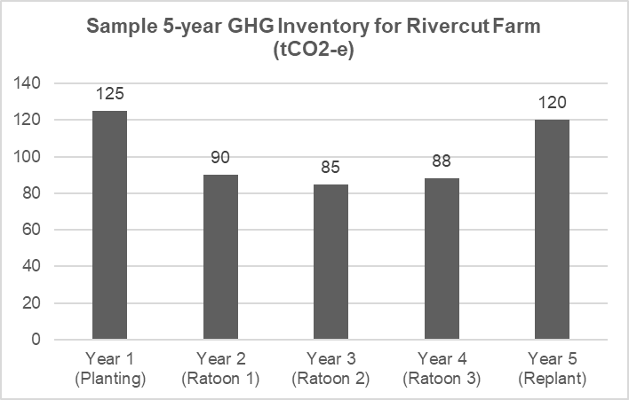
Temporal allocation of emissions results in yearly variability in emission estimates, with higher emissions in planting years compared to ratoon years. Both Rivercut Farm and the brewing company understand this variability and are both transparent in reporting of annual GHG inventories and consideration of the long-term average emissions and trends in their disclosures.
Rivercut Farm chooses internally to evaluate the GHG emissions of the crop on a 5-year cycle, so that planting vs planting and ratoon vs ratoon years can be compared. This allows Mike to review his emissions over time, isolate key drivers of emissions and account for other annual fluctuations. This approach allows Rivercut Farm to highlight areas of improvement, understand the areas which impact the crops emission portfolio, and isolates emission sources within his control and those outside his control. This knowledge will allow Mike to better communicate with their supply chain.
Case Study 4b - Longer than 12-month production/lifecycles
Entity Description
Southsea Salmon Farm is an Atlantic salmon producer located in Tasmania who operates a hatchery and marine farm. Southsea salmon spend the first 10-16 months in a freshwater hatchery environment until they become smolts. After smoltification, they are transferred to saltwater sea pens where they remain for a further 15-18 months until they reach a harvestable size.
Terry owns and operates Southsea Salmon Farm, the farm has the Feed Standard and Farm Standard certification with the Aquaculture Stewardship Council (ASC). The ASC has recently updated their requirements for certification under the Farm Standard to include GHG reporting as part of their accreditation program. In order to comply with the updated certification requirements, Southsea proceeds to produce an annual GHG inventory. As the production cycle of an Atlantic salmon generally falls between 2 and 3 years from fertilised egg to harvest-ready fish, Southsea is unsure how to report their emissions. Under the certification, the ASC requires all indicators to be reported annually, therefore, Southsea shall produce a report that reports the emissions in the year the activity takes place.
Identifying the impact of extended production or lifecycles
Terry needs to consider a number of emissions estimation Modules related to aquaculture. The impact of longer production or lifecycles for relevant emissions Modules to be adopted by Southsea Salmon Farm are defined below.
Module | Reporting Category | Description
Fuel use | Scope 1 | Influenced by production stage/lifecycle requirements of salmon
Solid Waste Treatment | Scope 1 | Influenced by production stage/lifecycle requirements of salmon
Wastewater Treatment | Scope 1 | Influenced by production stage/lifecycle requirements of salmon
Purchased electricity | Scope 2 | Southsea Salmon Farm operation
Various scope 3 Modules | Scope 3 | Purchases and management practices for Southsea Salmon Farm

As the total emissions for producing Atlantic Salmon are not contained within a 12-month period, it causes Southsea’s GHG inventory to fluctuate from year-to-year. Despite the multi-year production cycle, Terry ensures the GHG inventory aligns with the 12-month reporting window to report his annual emission to the ASC.
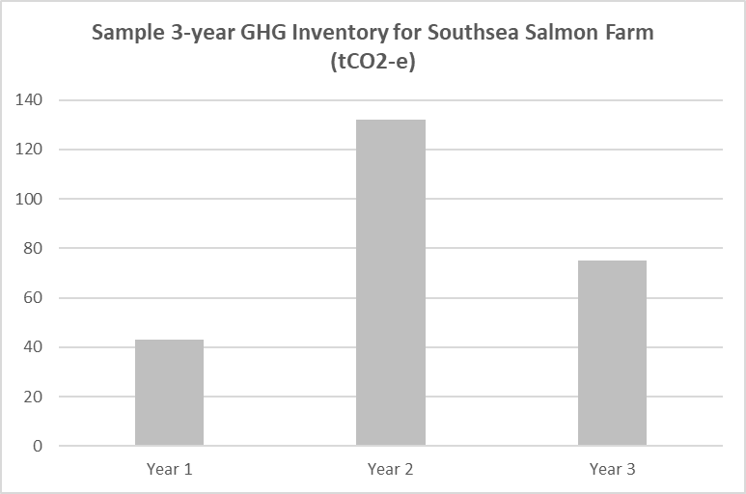
*Emissions are for example demonstration only and are not representative of aquaculture Atlantic Salmon production.
Southsea typically operates a hatchery phase for 15 months and a marine pen phase for 16 months. Despite occurring on a continuous cycle, where fish are always present in hatchery and marine stages, the majority of emissions in aquaculture salmon production occur during the seawater stage while in marine pens. Therefore, years that capture a significant proportion of the ‘finishing’ phase in seawater have higher emissions when compared to years which are primarily capturing the hatchery and early marine pen stages. This temporal allocation of emissions results in yearly variability in emissions estimates.
Both Southsea Farm and the ASC understand this variability, Terry is transparent in reporting of annual GHG inventories to stakeholders, with consideration of the long-term average emissions and trends in their disclosures.
Southsea chooses internally to evaluate the GHG emissions of the salmon on a 3-year cycle that aligns with the production cycle of the fish. This allows Terry to review his emissions over time, isolate key drivers of emissions and account for other annual fluctuations. This approach allows Southsea to highlight areas of improvement, understand the areas which impact the salmon’s emission portfolio, and isolates emission sources within his control and those outside his control. This knowledge will allow Terry to better communicate with their supply chain.

Case Study 5 – Transferring manure between entities
Entity Description
Feathervale Farm is a commercial poultry enterprise located in South Australia and produces broilers under a continuous production system. Manure is regularly cleaned from the poultry shed, composted and stored on-site. Feathervale gives a proportion of their manure to other local farms to be used as an organic fertiliser.
Wildridge Horticulture is a neighbouring horticulture producer who receives poultry manure from Feathervale farm and applies it to their potato, squash and bulb crops as part of their nutrient management plan.
Both entities are required to prepare annual GHG inventories for their respective supply chains and are unsure how to account for the emissions associated with the poultry manure.
First the boundary of control needs to be established for the manure as this will impact what scope various emissions are classified as. In this example, the ownership and control of the poultry manure is transferred from Feathervale Farm to Wildridge Horticulture once it is delivered. The emissions accounting responsibility for the manure between each entity is as follows:
Module | Reporting Category | Responsible Entity
Manure management | Scope 1 | Feathervale is responsible for all emissions associated with the production and storage of poultry manure while manure is located within the boundary of Feathervale farm.  However, the proportion of manure sold to Wildridge Horticulture shall be excluded from manure applied to soil calculations, see Chapter 4 Section 4.6 equations 4.6.1.9. Therefore, Feathervale keeps track of the portion of manure leaving the property compared to the amount which remains annually.
Fertiliser use | Scope 1 | Wildridge Horticulture is responsible for all emissions associated with applying manure to soil for the amount of manure purchased from Feathervale

Feathervale reports all emissions up to point of transfer of the manure as the manure is under the operational control of Feathervale Farm. Once the manure has been transferred to Wildridge, all further emissions from land application and deposition on Wildridge Horticultures’ land is excluded from Feathervale Farm’s GHG assessment as this is beyond the cradle to farm-gate boundary they are adopting. However, Wildridge Horticulture would account for the application of the manure once it is delivered to their farm.
All remaining manure which is retained by Feathervale is the sole responsible of Feathervale farm and they retain the responsibility for the emissions of the manure.
Feathervale may supply records of manure quantities, nitrogen content (if known) and sale date to support Wildridge Horticulture’s calculations.

Spatial boundary considerations
For some Methods, emissions factors and default parameters vary by location, reflecting differences in climate, rainfall, soil type, and management practices. As these variables can significantly influence GHG emissions it is essential that entities apply the correct spatial boundary when estimating emissions.

Application across multiple spatial boundaries
When an entity’s operations span multiple states, regions, or climate zones, and the Guidance provides location-specific emission factors or data, one of the following Method 1 or 2 approaches shall be applied.
Method 1:
Use the location-specific emission factors or data for the state, region, or climate zone reflective of the location of the majority of the entity’s physical footprint.
Using a single emission factor for the entire area, based on the region with the majority of activity, can lead to biased results if emission factors differ significantly across regions. It is recommended, where possible, a Method 2 approach is applied.
Method 2:
- stratify activities across regions. This may even apply within a single property or organisational boundary
- apply location-specific emission factors or default parameters as required
- document and transparently disclose all methodological assumptions.
The stratification approach requires completion of the following steps.
- Define the activity data metric (e.g., hectares, head of livestock, or hours of equipment use).
- Allocate the activity data metric to the stratified region or zone.
- Apply the appropriate location-specific emission factor or parameter to estimate the total emissions from each stratum.
- If detailed sub-entity or paddock-level data is unavailable, to match the activity to the geographic area (i.e. the production occurring in respective regions), then use a proportional allocation method. For example, if 30% of the property lies in one region, and 70% in another, allocate activity data accordingly and apply the relevant region-specific emission factors.
- Sum emissions across all strata to calculate the total emissions estimate.
A stratified approach aligns with the principle of completeness and ensures that all material sources are accounted for. Additionally, third-party verifiers typically expect regional disaggregation when emission factors vary materially.
However, applying a single emission factor for Method 2 may be acceptable when:
- the region in question represents a small proportion (typically less than 5–10%) of the total activity area
- the emission factors across regions are similar, such that the impact on total emissions is immaterial.
In such cases, the assumption shall be clearly documented and justified as a simplification.

Region, leaching, climate, and rainfall zones
If entities are required to apply Modules 4-6 (Manure management, Fertiliser and Residue Management) they shall identify the relevant climate zone, temperature zone, rainfall zone, and leaching zone in which their operations are located using the instructions at 1.8.1. Table 1.3 summarises the classifications that exist for each zone. Select the first zone that matches the criteria experienced on your holding/s.
Climate data for rainfall, evapotranspiration and soil water accumulation may be sourced from the following resources:
- eWater Toolkit
- TERN
- Soil and Landscape Grid of Australia
- Department of Primary Industries and Regional Development
- My Climate View
- Bureau of Meteorology.
Additionally, pasture, range and paddock beef cattle entities that are using default (Method 1) liveweight or liveweight gain data shall identify the relevant region(s) in which their operations are located.
Climate Zone
The climate zone shall be selected based on the long-term mean annual temperature, annual precipitation, annual frost days, elevation, and the ratio of precipitation to evapotranspiration.
Question Reference 1.2.
Current guidance requires long-term mean annual climate data to assess climate zone aligned with international guidelines and the National Inventory Report approach. Are long-term annual climate means the most appropriate climate metric for entity-level emissions estimation? What time period should be used to calculate a long-term climate average for emissions estimation?
Climate zones are used to identify emission factors for direct nitrous oxide emissions based on the climate zone (wet vs dry) in which the farm is located. Wet and dry climates used in this classification are a subset of the temperate and tropical climate zones demonstrated in Table 1.2.
Table 1.2: Translating climate zones to wet and dry zones.
Climate Zone | Wet or Dry Zone
Tropical montane | Wet
Tropical wet | Wet
Tropical moist | Wet
Tropical dry | Dry
Warm temperate moist | Wet
Warm temperate dry | Dry
Cool temperate moist | Wet
Cool temperate dry | Fry

Wet and dry zones are demonstrated on the map provided in Figure 1.4. A GIS-compatible version of this map will be made available for download with Version 1 of the Guidelines. If an entity crosses multiple regions the guidance provided in Section 1.8.1 shall be applied to select the appropriate default data.
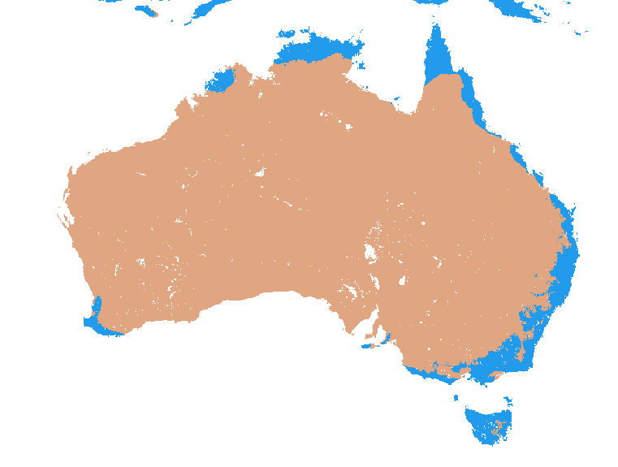
Figure 1.3: Map of climate zones in Australia
Temperature Zone
Temperature zones are defined by the mean annual temperature (MAT). This MAT is used to select the appropriate methane conversion factor for manure management if Method 2 is applied. If Method 1 is used for identifying methane conversion factors temperature zone are not required.
Rainfall Zone
Rainfall zones are split into two levels: high rainfall and low rainfall. The threshold between the two zones is an annual rainfall of 600 mm. All areas of receiving more than 600 mm of rain in the reporting year are classified as the high rainfall zone. Those areas below 600 mm annual rainfall are classified as low rainfall.
Rainfall data from the year of reporting may be used. It is recommended to use rainfall data collected directly on-site, where this is done reliably and accurately, or use data from a local weather station.
Rainfall zone is used in combination with production type (irrigated vs non irrigated, or crop-specific) to determine the emission factors used to estimate to nitrous oxide emissions from inorganic fertiliser application, or atmospheric deposition of manure.
Leaching Zone
Areas are subject to leaching (i.e., in the leaching zone) when either of the following occurs:
- the annual precipitation exceeds the sum of evapotranspiration and soil water holding capacity, or
- the land is irrigated (except drip irrigation).
Climate data should be used when ∑(rain) > ∑(ET₀) + soil water holding capacity for any non-irrigated enterprises, to determine whether they are located in a leaching zone. If a farm is in a leaching zone the nitrous oxide emissions associated with leaching and runoff from manure management and fertiliser application shall be included in the emissions estimate.
Regions
For the use of default (Method 1) liveweight, liveweight gain and methane conversion factors for beef cattle pasture range and paddock data entities shall identify the relevant region(s) in which their operations are located. Regions are based on the map provided in Figure 1.4. A GIS compatible version of this map will be made available for download when Version 1 of the Guidelines are published mid-year. If an entity crosses multiple regions the guidance provided in Section 1.8.1 shall be applied to select the appropriate default data.

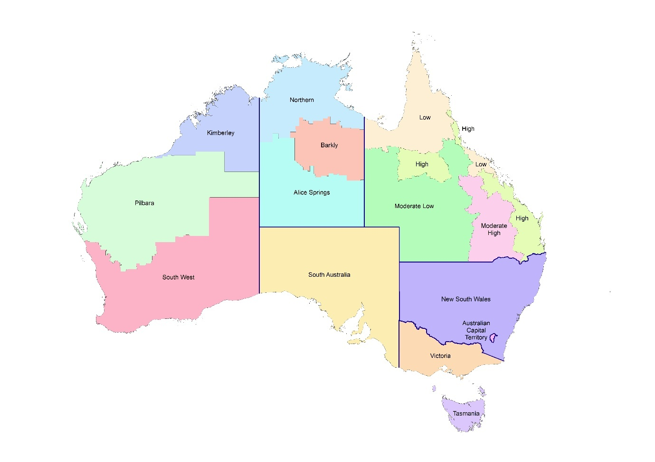
Figure 1.4: Map of for beef cattle pasture, range and paddock
Table 1.3: Climate and Rainfall zone classifications and definitions
Zone | Classification | Definition
Climate zone |  | MAT | MAP | Frost days per year | Elevation | MAP:PET
 | Tropical montane | > 18 ºC | Any | ≤ 7 | >1000 m | N/A
 | Tropical wet | > 18 ºC | > 2000 mm | ≤ 7 | ≤ 1000 m | N/A
 | Tropical moist | > 18 ºC | > 1000 mm - ≤ 2000 mm | ≤ 7 | ≤ 1000 m | N/A
 | Tropical dry | > 18 ºC | ≤ 1000 mm | ≤ 7 | ≤ 1000 m | N/A
 | Warm temperate moist | > 10 - ≤ 18 ºC | Any | Any | Any | >1
 | Warm temperate dry | > 10 - ≤ 18 ºC | Any | Any | Any | ≤1
 | Cool temperate moist | > 0 ºC - ≤ 10 ºC | Any | Any | Any | >1
 | Cool temperate dry | > 0 ºC - ≤ 10 ºC | Any | Any | Any | ≤1
Temperature zone | Warm | MAT ≥ 26 ºC
 | Temperate | MAT 15 - 25 ºC
 | Cool | MAT ≤ 14 ºC
Rainfall zone | High rainfall | Annual rainfall > 600mm
 | Low rainfall | Annual rainfall ≤ 600mm
Leaching zone* | Leaching occurs | $\sum{(rain)}>\sum{\left(ET_{0}\right)+soil water holding capacity}$
 | Leaching does not occur | $\sum{(rain)}≤\sum{\left(ET_{0}\right)+soil water holding capacity}$
Note: MAT = mean annual temperature, MAP = mean annual precipitation, PET = potential evapotranspiration.*Irrigation is included in the assessment of leaching zone (except drip irrigation).

Case Study 6 – Selection of leaching, climate and rainfall zones in dryland system
Entity A
Ironbark Plains is a 3200 ha dryland broadacre cropping enterprise located in the central west of New South Wales. The farm is managed by Shane, and operates a non-irrigated wheat, canola and barley rotation, relying entirely on seasonal rainfall and stored soil moisture. No supplementary irrigation is used on any paddock.
Shane has been asked to complete an annual GHG inventory for the farm. For estimation of emissions from fertiliser application and return of crop residues to the soil, Shane is required to identify the relevant climate zone, rainfall zone, and leaching zone applicable to the farm. Shane uses long term data from the Bureau of Meteorology from a bureau weather station closest to Ironbark Plains to determine the long term mean annual rainfall for the region. Shane also knows from his own weather station that on average Ironbark Plains has more than 7 days of frost per year.
Table 1.4: Summary of data obtained from the Bureau of Meteorology
Parameter | Data
Long-term mean annual rainfall | 464mm
Long-term mean annual temperature | 16°C

Shane is able to use the data from the weather station in combination with national datasets, and the evapotranspiration data set from TERN, to confirm Ironbark Plains is located in the following climatic and rainfall zone classifications.
Table 1.5: Climate and rainfall classifications for Ironbark Plains, including definitions.
Zone | Classification | Definition
 |  | MAT | Frost days | MAP:PET
Climatic zone | Warm temperate dry | 10°C - 18°C | >7 days | ≤1
Rainfall zone | Low rainfall | Annual rainfall ≤ 600mm

Shane reviews the spatial leaching map provided alongside the Guidance to determine if Ironbark Plains is in a leaching zone. Based on the location of the farm, Shane confirmed the farm is not located within a leaching zone. Therefore, Shane applies the FracWET parameter as 0 while estimating leaching and run-off emissions.
While completing emission estimation modules Shane ensures to select dry climate and/or low rainfall when selecting emission factors for fertiliser and agricultural residual management modules.

Herd flow and liveweight estimation
When estimating livestock emissions, the accuracy of reported stock numbers and their liveweight (LW) and liveweight gain (LWG) during the reporting period, can significantly influence GHG estimates. Two methods are presented to reflect situations where such data is collected by producers in varying temporal scales.
The following data shall be available under Method 1:
- Stock numbers for each livestock class within the entity at the first and last month of the reporting period and/or at the point of birth, death, purchase, or sale of the livestock class.
The following data shall be available under Method 2:
- stock numbers for each livestock class within the entity at the first and last month of the reporting period and/or at the point of birth, death, purchase, or sale of the livestock class
- liveweight and liveweight gain (where applicable) for each livestock class within the entity at the month of data collection where required for emissions estimates (beef pasture, range, and paddock, dairy, and sheep only).
For both Method 1 and Method 2, livestock numbers are assumed to be constant between data entry points, unless a birth, death, sale or purchase has been recorded. For Method 1 for sheep and beef pasture, range and paddock, the numbers of livestock are estimated seasonally to align with default liveweights and liveweight gain values (see Chapter 3 Sections 3.2.1.1, 3.3.1.1 and 3.4.1.1, and Chapter 4 Sections 4.2.1.1, 4.3.1.1 and 4.4.1.1, Method 1 for liveweight and liveweight gain). Livestock numbers shall be rounded up if seasonal estimates do not produce a whole number. For Method 1 for dairy cattle, liveweight of milking herds and mature breeding stock may remain constant throughout the year.
For Method 2, where liveweight for different livestock classes is available at multiple points throughout the year, liveweight and liveweight gain will be averaged between data points based on the number of days between liveweight measurements (see Chapter 3 Sections 3.2.1.2, 3.3.1.2 and 3.4.1.2, and Chapter 4 Sections 4.2.1.2, 4.3.1.2 and 4.4.1.2, Method 2 for liveweight gain).
Producers may use a combination of default liveweights for some livestock classes and their own liveweight data (a mix of Method 1 and Method 2). See Chapter 3, Sections 3.2.1.2, 3.3.1.2 and 3.4.1.2, and Chapter 4, Sections 4.2.1.2, 4.3.1.2 and 4.4.1.2, Method 2 for liveweight.
Unless otherwise specified, it is assumed stock counts and liveweights are reported at the 1st of the month. Specifically, if liveweights are reported in consecutive months it will be assumed 28, 29, 30 or 31 days are between these measurements depending on the months of data collected. Method 2 may easily be modified to the annual period required for reporting (calendar or financial). Guidance in Section 1.6.1 on prioritising data collection applies when considering increasing the frequency of recording and reporting of livestock numbers and liveweight data.
Case Study 7 – Herd Flow (minimum data option)
Entity A
Redbrook Station is a 1000 ha beef breeding property located in Northern Queensland. Redbrook runs 200 breeding cows in a spring calving system, and sells the calves as weaners the following winter, in August. The station is completing its annual GHG inventory, and has limited monthly stock numbers due to the extensive nature of the operation. Redbrook’s annual GHG inventory is estimated and reported on a financial year basis from 1 July to 30 June, and a stock count of each livestock class is conducted in July.
Redbrook sold all bull and heifer calves in August to a beef finishing property. The producer recorded no additional sales, births or deaths in the other livestock classes for August and as such livestock numbers are assumed to stay the same.
Table 1.6: Example minimum input data requirements for GHG emissions estimation: July – August
 | Numbers on hand
Livestock Class |  | Jul | Aug
Cows >3 year | Head | 200 | 200
Breeding Bulls | Head | 7 | 7
Bull calves | Head | 98 | 0
Heifer calves | Head | 102 | 0

Redbrook starts calving in November and finishes calving in March. Calving numbers are difficult to track per month due to the extensive nature of the operation. The producer rounds up all cattle at the end of the calving season in March, and counts all livestock. All calves born in the period are attributed to March as actual number of births per month are unknown. Any unproductive stock also leaves Redbrook in March. The updated stock numbers are recorded for March; no other sales or deaths were recorded from August to February so numbers are assumed to stay the same between recording events.
Table 1.7: Example minimum input data requirements for GHG emissions estimation: July – March
 | Numbers on hand
Livestock Class |  | Jul | Aug | Sep | Oct | Nov | Dec | Jan | Feb | Mar | Apr | May | Jun
Cows >3 year | Head | 200 | 200 |  |  |  |  |  |  | 195
Breeding Bulls | Head | 7 | 7 |  |  |  |  |  |  | 6
Bull calves | Head | 98 | 0 |  |  |  |  |  |  | 95
Heifer calves | Head | 102 | 0 |  |  |  |  |  |  | 100

Redbrook was not able to re-count livestock again before the end of the inventory period in June, but no additional births, deaths or sales were recorded, so the producer assumes the closing stock numbers match the most recent stock count from March.
As only the Method 1 data is available these livestock numbers are translated into seasonal categories to allow seasonal defaults for live weight (LW) and liveweight gain (LWG) to be applied (Method 1). This is demonstrated
in Table 1.7. It is assumed the numbers of animals remains constant between stock counts. The number of cows>3 years in spring and summer is 200 for each season and the number of breeding bulls stays constant at 7. In Autumn calves are born and counted and their numbers are assumed to stay constant at 95 and 100 respectively for this season. Another stock count of cows and bulls is performed at this time and the new values are used for autumn. As winter crosses the reporting period and there are different stock counts for each class a weighted average is calculated across the values recorded in the winter months and this number is reported for winter.
For example:
Number of Cows > 3 years in Winter = (200 x 31) + (200 x 31) + (195 x 30) / (31 + 31 + 30) = 198
Number of Breeding Bulls in Winter = (7 x 31) + (7 x 31) + (6 x 30) / (31 + 31 + 30) = 7
Number of Bull Calves in Winter = (98 x 31) + (0 x 31) + (95 x 30) / (31 + 31 + 30) = 64
Number of Heifer Calves = (102 x 31) + (0 x 31) + (100 x 30) / (31 + 31 + 30) = 67
Table 1.8 demonstrates Seasonal defaults for live weight (LW) and liveweight gain (LWG) may be added based on producer location. Redbrook is located in a moderate/high region of Queensland, so those values found in Chapter 12; Appendix Table 12.1.1.2 and 12.1.1.4.
Table 1.8: Complete translation of minimal data requirements to Method 1 emission estimation parameters
 | Values as used in calculations
Livestock Class |  | Spring  Sept-Nov | Summer  Dec-Feb | Autumn  Mar-May | Winter  June-Aug
Cows >3 year | Head | 200 | 200 | 195 | 198
 | LW (kg) | 467 | 477 | 471 | 484
 | LWG (kg/day) | -0.19 | 0.63 | 0.04 | -0.02
Breeding Bulls | Head | 7 | 7 | 6 | 7
 | LW (kg) | 674 | 669 | 685 | 692
 | LWG (kg/day) | -0.19 | 0.19 | 0.13 | -0.06
Bull calves | Head | 0 | 0 | 95 | 64
 | LW (kg) | - | - | 172 | 241
 | LWG (kg/day) | - | - | 0.7 | 0.32
Heifer calves | Head | 0 | 0 | 100 | 67
 | LW (kg) | - | - | 172 | 208
 | LWG (kg/day) | - | - | 0.52 | 0.25

Case Study 8 – Herd Flow (detailed data option)
Entity B
Cloveline Sheep Farm is a 1000 ha self-replacing Merino enterprise in Tasmania. Cloverline runs 2200 breeding ewes, supported by rams and replacement ewe lambs, with lambing occurring in late winter, early spring (August-September). The producer keeps detailed monthly stock records, tracking head counts, births, sales and deaths, supported by regular weigh-ins at weaning, pre-joining, and drafting.
The producer is completing its annual GHG inventory, and has chosen to use their more detailed data for stock numbers and liveweights in the creation of a more specific GHG emissions estimation. The producer took a stock count and weighed all livestock before the beginning of lambing in July.
Cloveline counts as they are born, and assigns total number of lambs and average lamb weight per livestock class to August as the majority of lambing takes place in this month. There were no recorded deaths or sales for other livestock classes, so numbers are assumed to remain the same, the ewes and rams were not weighed again.
Table 1.9: Example detailed data input for more specific GHG emissions estimation: July – August
 | Numbers on hand
Livestock Class |  | Jul | Aug
Ewes | Head | 2200 | 2200
 | LW (kg) | 60 | -
Rams | Head | 40 | 40
 | LW (kg) | 70 | -
Maidens | Head | 250 | 250
 | LW (kg) | 50 | -
Ewe lambs | Head | 0 | 1000
 | LW (kg) | - | 15
Male lambs | Head | 0 | 1000
 | LW (kg) | - | 15

The producer proceeds to count and weigh the livestock at different times throughout the year in line with various operational events. The information is stored in stock records; an example entry is demonstrated in Table 1.10.
Table 1.10: Demonstrating example livestock stock record entry: September – June
September | -
October | 2200 ewes average 55kg – sold 50 ewes
November | 40 Rams averaging 70kg – sold 10 rams
December | 250 maidens averaging 55kg – sold 5 maidens  1000 ewe lambs averaging 35kg – sold 500 ewe lambs  100 male lambs averaging 35kg – sold 750 male lambs
Jan | -
Feb | 250 male lambs averaging 40kg
March | 2150 ewes averaging 60kg – sold 450 ewes  30 rams averaging 70kg – brought 10 rams  250 male lambs averaging 40kg – sold 250 male lambs
April | -
May | -
June | 1700 ewes averaging 65kg  40 rams averaging 65kg  245 maidens averaging 60kg – 5 maidens sold  250 ewe lambs averaging 50kg

This information may be translated into the detailed data input table as demonstrated in Table 1.12. All deaths, births and sales are recorded in the livestock stock records, so numbers between recording events are assumed to remain unchanged. Counting and weighting events are bolded in Table 1.11 to demonstrate when livestock numbers have changed based on farm records.

Table 1.11: Example detailed data input for more specific GHG emissions estimation
 | Numbers on hand each month
Livestock Class |  | Jul | Aug | Sep | Oct | Nov | Dec | Jan | Feb | Mar | Apr | May | Jun
Ewes | Head | 2200 | 2200 | 2200 | 2150 | 2150 | 2150 | 2150 | 2150 | 1700 | 1700 | 1700 | 1700
 | LW (kg) | 60 | - | - | 55 | - | - | - | - | 60 | - | - | 65
Rams | Head | 40 | 40 | 40 | 40 | 30 | 30 | 30 | 30 | 40 | 40 | 40 | 40
 | LW (kg) | 70 | - | - | - | 70 | - | - | - | 70 | - | - | 65
Maidens | Head | 250 | 250 | 250 | 250 | 250 | 245 | 245 | 245 | 245 | 245 | 245 | 240
 | LW (kg) | 50 | - | - | - | - | 55 | - | - | - | - | - | 60
Ewe lambs | Head | 0 | 1000 | 1000 | 1000 | 1000 | 500 | 500 | 500 | 500 | 500 | 500 | 250
 | LW (kg) | - | 15 | - | - | - | 35 | - | - | - | - | - | 50
Male lambs | Head | 0 | 1000 | 1000 | 1000 | 1000 | 250 | 250 | 250 | 0 | 0 | 0 | 0
 | LW (kg) | - | 15 | - | - | - | 35 | - | 40 | 0 | - | - | -

Liveweight gain is assumed to have occurred linearly between data entry points.
For example, the weight gain between October and March for breeding ewes is calculated by:
Average weight gain per day= (60-55)/(30+31+31+28+31) = 0.03
Average weight for November = 55 + (30 x 0.03) = 56
Table 1.12 demonstrates the more detailed data on stock numbers and liveweights held by Cloveline farm is translated to create a more specific data which will allow for more specific GHG emission estimate.

Table 1.12: Translation of more detailed input data to Method 2 emission estimation parameters
 | Numbers as used in calculations including specific weights
Livestock Class |  | Jul | Aug | Sep | Oct | Nov | Dec | Jan | Feb | Mar | Apr | May | Jun
 | Days | 31 | 31 | 30 | 31 | 30 | 31 | 31 | 28* | 31 | 30 | 31 | 30
Ewes | Head | 2200 | 2200 | 2200 | 2150 | 2150 | 2150 | 2150 | 2150 | 1700 | 1700 | 1700 | 1700
 | LW (kg) | 60 | 58 | 56 | 55 | 56 | 57 | 58 | 59 | 60 | 61 | 63 | 65
 | LWG (kg/day) | -0.05 | -0.05 | -0.05 | -0.03 | 0.03 | 0.03 | 0.03 | 0.03 | 0.03 | 0.05 | 0.05 | 0.00
Rams | Head | 40 | 40 | 40 | 40 | 30 | 30 | 30 | 30 | 40 | 40 | 40 | 40
 | LW (kg) | 70 | 70 | 70 | 70 | 70 | 70 | 70 | 70 | 70 | 68 | 66 | 65
 | LWG (kg/day) | 0.00 | 0.00 | 0.00 | 0.00 | 0.00 | 0.00 | 0.00 | 0.00 | 0.00 | -0.05 | -0.05 | -0.05
Maidens | Head | 250 | 250 | 250 | 250 | 250 | 245 | 245 | 245 | 245 | 245 | 245 | 240
 | LW (kg) | 50 | 51 | 52 | 53 | 54 | 55 | 56 | 57 | 57 | 58 | 59 | 60
 | LWG (kg/day) | 0.03 | 0.03 | 0.03 | 0.03 | 0.03 | 0.03 | 0.03 | 0.03 | 0.03 | 0.03 | 0.03 | 0.03
Ewe lambs | Head | 0 | 1000 | 1000 | 1000 | 1000 | 500 | 500 | 500 | 500 | 500 | 500 | 250
 | LW (kg) | - | 15 | 20 | 25 | 30 | 35 | 38 | 40 | 42 | 45 | 47 | 50
 | LWG (kg/day) | - | - | 0.16 | 0.16 | 0.16 | 0.08 | 0.08 | 0.08 | 0.08 | 0.08 | 0.08 | 0.00
Male lambs | Head | 0 | 1000 | 1000 | 1000 | 1000 | 250 | 250 | 250 | 0 | 0 | 0 | 0
 | LW (kg) | - | 15 | 20 | 25 | 30 | 35 | 38 | 40 | - | - | - | -
 | LWG (kg/day) | - | - | 0.16 | 0.16 | 0.16 | 0.08 | 0.08 | 0.08 | - | - | - | -
*Number of days to be adjusted if reporting period is a leap year

Case Study 9 – 18-month Herd Flow
Entity C
Mountview Farm is a beef farm in Northern Queensland that buys weaner steers for finishing. The producer buys all weaners in April, keeps them for 18 months until finishing and sells them the following October. The producer only has livestock numbers and weights from point of purchase and point of sale, but is required to conduct a 12-month GHG inventory for their processor.
Mountview Farm may use a detailed data input option as they can use the livestock numbers and weight information from point of purchase and point of sale to create a detailed data input table. The producer has the following information from their purchase and sales records.
- Purchase record = 1200 steers averaging 180kg (April Year 1)
- Sale record = 1195 steers averaging 528kg (October Year 2)
The producer decides to conduct the 12-month inventory assessment from April year 1 to April in year 2. The producer does not have reliable records for the 5 deaths that occurred, so the stock records remain constant from the purchase until the sale month. The liveweight is assumed to have occurred linearly.
For example, the weight gain between October and March for breeding ewes is calculated by:
Average weight gain per day= (528-180)/(30+ 31+ 30+ 31+ 31+ 30+ 31+ 30+ 31+ 31+ 28+ 31+ 30 + 31+ 30+ 31+ 31+ 30) = 0.635
Average weight for May = 180 + (30 x 0.635) = 199
Table 1.13: Linear application of livestock numbers and weights over an 18-month period
 |  |  | Year 1 |  |  |  |  |  |  |  |  |  |  |  |  |  | Year 2
 |  |  | Apr | May | Jun | Jul | Aug | Sep | Oct | Nov | Dec | Jan | Feb | Mar | Apr |  | May | Jun | Jul | Aug | Sep | Oct
 |  | Days | 30 | 31 | 30 | 31 | 31 | 30 | 31 | 30 | 31 | 31 | *28 | 31 | 30 |  | 31 | 30 | 31 | 31 | 30 | 31
Livestock Class | Steers <1 | Head | 1200 | 1200 | 1200 | 1200 | 1200 | 1200 | 1200 | 1200 | 1200 | 1200 | 1200 | 1200 | 1200 | Steers >1 | 1200 | 1200 | 1200 | 1200 | 1200 | 1195
 |  | LW (kg) | 180 | 199 | 218 | 237 | 257 | 277 | 296 | 315 | 334 | 354 | 374 | 392 | 411 |  | 430 | 450 | 469 | 489 | 508 | 528
*Number of days to be adjusted if reporting period is a leap year
The producer takes the data specific to the 12-month assessment period chosen for the inventory and adds liveweight gain, which is assumed to have occurred linearly. Table 1.14 demonstrates how the stock numbers and liveweights held by Mountview Farm from two points in time, are translated to create specific data which will allow Method 2 herd flow approach to be applied.
Table 1.14: Translation of 18-month data into a 12-month inventory aligned detailed input data for Method 2 emission estimation parameters
 |  |  | Numbers as used in calculations including specific weights
 |  |  | Apr | May | Jun | Jul | Aug | Sep | Oct | Nov | Dec | Jan | Feb | Mar | Apr
 |  | Days | 30 | 31 | 30 | 31 | 31 | 30 | 31 | 30 | 31 | 31 | *28 | 31 | 30
Livestock Class | Steers <1 | Head | 1200 | 1199 | 1199 | 1199 | 1198 | 1198 | 1198 | 1198 | 1197 | 1197 | 1197 | 1196 | 1196
 |  | LW (kg) | 180 | 199 | 218 | 237 | 257 | 277 | 296 | 315 | 334 | 354 | 374 | 392 | 411
 |  | LWG (kg/day) | 0.635 | 0.635 | 0.635 | 0.635 | 0.635 | 0.635 | 0.635 | 0.635 | 0.635 | 0.635 | 0.635 | 0.635 | 0.635
*Number of days to be adjusted if reporting period is a leap year

Case Study 10 – Herd Flow (Dairy Australia Data)
Entity A
Southvale Dairy is an 800 ha pasture-based dairy located in northern Victoria. Southvale milks 480 Ayrshire cows, in a spring-calving system. The farm rears its own replacements, selling surplus calves at around one-year old.
Southvale is completing its annual GHG inventory for internal reporting and processor requirements. The inventory is prepared using the Australian financial year (1 July to 30 June). Due to operational constraints, the farm does not maintain reliable month-by-month livestock numbers across all classes, therefore the farm chooses to look at ‘opening and closing’ stock numbers and support any stock changes with sales dockets and calf-rearing records. An example of this data can be found in Table 1.15.
Table 1.15: Example minimum data requirements for GHG emission estimation, July - June
 | Numbers on hand
Livestock Class |  | Jul | Aug | Sep | Oct | Nov | Dec | Jan | Feb | Mar | Apr | May | Jun
Cows >3 year | Head | 480 | 480 | 480 | 480 | 475 | 475 | 475 | 475 | 475 | 475 | 475 | 475
Breeding Bulls | Head | 10 | 10 | 10 | 10 | 10 | 10 | 10 | 10 | 10 | 11 | 11 | 11
Bull calves >1 | Head | 230 | 0 | 0 | 0 | 0 | 0 | 0 | 0 | 0 | 0 | 0 | 0
Bull calves <1 | Head | 0 | 0 | 102 | 205 | 205 | 205 | 205 | 205 | 205 | 205 | 205 | 205
Heifer calves >1 | Head | 250 | 210 | 210 | 210 | 210 | 210 | 210 | 210 | 210 | 210 | 110 | 110
Heifer calves <1 | Head | 0 | 0 | 135 | 270 | 270 | 270 | 270 | 270 | 270 | 270 | 270 | 270

Southvale only has birth weights and sale weights for the bull and heifer calves, and does not record live weight of milking cows or breeding bulls. Therefore, chooses to use default live weight (LW), specific to breed type, for their milking herd and default LW for their bulls. They assume that this default is an average liveweight for these animals during the year and consider LWG to be 0 for these livestock classes. The also assume a default weight for their Heifers >1 specific to breed type and a default liveweight gain (LWG) of 0.6 kg/head/day.
The farm uses their own farm records to determine LW and LWG of the calves, assuming this gain has occurred linearly between known data points. Example data can be found in Table 1.16.
Table 1.16: Southvale livestock stock record entry: September – June
September | -
October | Birth Weights  205 bull calves averaging 35kg  270 heifer calves averaging 30kg
November | -
December | -
Jan | -
Feb | Weighed while worming  205 bull calves averaging 169kg  270 heifer calves averaging 142kg
March | -
April | -
May | -
June | Weighed while re-grouping  205 bull calves averaging 231kg  270 heifer calves averaging 224kg

For example, the weight gain between October and February for the bull calves is calculated by:
Average weight gain per day= (169-35)/(30+31+31+28) = 1.12
Average weight for November = 35 + (30 x 1.12) = 68.5
Southvale will be able to utilise known data points and default data to uptake a Method 2 emission estimation for these livestock categories.

Frequently Asked Questions
This section covers some of the concepts in the Case Studies but in a different format to accommodate different user needs. Suggestions of other FAQs to include are welcome.
- What’s the difference between Method 1 and Method 2?
- Method 1: Uses default data (like national averages) with some basic records from producers. Easier and quicker, but less precise.
- Method 2: Uses your own detailed records (like livestock weights or fertiliser amounts). More accurate, may be required for reporting or to show the benefits of your management practices.
See Section 1.6 for more guidance.
- Do I need to use Method 2 straight away?
Not necessarily. Start with Method 1 if you don’t have detailed data. Move towards Method 2 over time, especially for major emission sources or if required by banks, buyers, or certification schemes. See Box 1 for more guidance.
- I run both livestock and cropping – how do I account for everything?
You’ll need to apply the Modules for each relevant activity (e.g. enteric fermentation, manure management, fertiliser use, crop residues, fuel use). Together they give a complete GHG estimate. See Case Study 1 for more guidance
- I have solar panels. How does this renewable energy get included in my estimates?
Unlike grid supplied power, renewable energy produced on-site produces zero emissions. In other words, the emissions factor applied to a kilowatt hour of renewable energy is 0. The impact of renewable energy on your GHG estimates comes from a lowering of the total kilowatt hours you draw from the grid which has an emissions factor greater than 0.
Any renewable energy that is generated on your site but sold off-site shall not be reflected in inventory totals. Inclusion of renewable energy will impact Scope 2 purchased electricity, and Scope 3 upstream emissions of electricity within the inventory assessment.
See Chapters 14 and 15 for estimation methods for Scope 2 and 3 electricity.
- How do I account for emissions from lime application in one year that affects yield in subsequent years?
Agricultural activities vary over a set period of years, such that activities (and corresponding GHG fluxes) in one year differ from those in other years within the same cycle. According to the GHG Protocol guidelines activities that do not occur every year, such as liming, shall be reported for in the year the activity takes place. This means if lime is applied once every three years, all emissions associated with that lime application shall be reported in the year of application, not spread evenly across the three years. The rationale is to maintain transparency, accuracy, and temporal integrity of the emissions data. In practice, this requires reporters to track the actual timing of occasional activities (e.g. liming events) and include zero emissions for years in which no liming occurs. If desired for communication purposes (e.g. reporting commodity-based emissions intensities), emissions may be analysed as a multi-year average, but this shall not replace annual accounting.
See Section 1.6.1, Box 2 and Case Studies 3 and 4 for more context and guidance.
- What types of records do I need to keep for reporting?
At minimum, for a livestock enterprise you need:
- Stock numbers (by class) at key times in the year.
- Amounts of fertiliser, lime, and chemicals used.
- Fuel and electricity use.
- Any purchases like livestock or inputs.
At minimum, for a non-livestock enterprise you need:
- Area and production of crop
- Amounts of fertiliser, lime, and chemicals used.
- Fuel and electricity use.
- Any purchased inputs.
The more accurate your records, the better your estimate. Refer to Section 1.6 and Data Tables in relevant Modules for more guidance open sources of data and guidance on Quality Assurance and Quality Control.

Key terms
Accuracy represents the degree to which an estimate reflects the true value of the quantity being measured. In practice, it's about how close your GHG estimates are to the actual emissions or removals. It depends on both the correctness of the methods and the quality of the input data.
Agistment is an arrangement between a stock owner and the owner of a short-term supplier of feed. Agistments are typically defined for a shorter period of time than pasture or grazing leases.
Annual is defined as a 12-month period, either a calendar or financial year, or other specified 12-month period which is relevant to the operations under consideration.
Carbon dioxide equivalent (CO₂e) is a standard unit for comparing emissions of different greenhouse gases by expressing them as the amount of CO₂ that would have the same warming effect over a set period (usually 100 years).
Default data is readily available based on national statistics or emission factors and additional parameters to provide an option for estimation where more specific data is not available.
Greenhouse gas (GHG) is a gas that absorbs and emits radiation causing the greenhouse effect. These gases include the 7 greenhouse gases listed in the Kyoto Protocol—carbon dioxide (CO₂); methane (CH₄); nitrous oxide (N₂O); hydrofluorocarbons (HFCs); nitrogen trifluoride (NF₃); perfluorocarbons (PFCs) and sulphur hexafluoride (SF₆). GHGs differ in their potency as a GHG and their atmospheric lifetime.
Liveweight (LW) is the average liveweight for each stock class at a defined point in time.
Liveweight gain (LWG) is the average weight gain per day.
Supply chain is the network of systems involved in producing a product or service, from extraction of raw materials, through to the final customer.
Materiality in the context of greenhouse gas inventories refers to the significance of emission sources or categories, determining which ones are important enough to warrant inclusion and detailed tracking. By applying a materiality threshold, often a specific percentage of total emissions, resources can be focused on the most impactful aspects of a GHG inventory, ensuring that significant data, errors, or omissions that could influence user decisions are identified and addressed.
Methods are the procedures for measurement and estimation of GHG emissions and removals. Higher level methods are generally considered to be more accurate.
Reporting entity is the entity responsible for developing the greenhouse gas estimate and may be selecting various methods based on assessing availability of data.
Value chain is the process or activities which a company adds value to a product or service, at any point in the supply chain.

The agriculture sector methods in the National Inventory Report are currently being updated. The methods provided in the Guidance reflect the most up to date information on the proposed changes and may be revised before publication.
eWater Toolkit climate dataset is available at: https://toolkit.ewater.org.au/Tools/Category-Climate
TERN actual evapotranspiration dataset is available at: https://portal.tern.org.au/metadata/TERN/9fefa68b-dbed-4c20-88db-a9429fb4ba97
The NIR uses the Soil and Landscape Grid of Australia Drained Upper Limit Volumetric Water Content 0-30cm for soil water holding capacity. More information is available at: https://esoil.io/TERNLandscapes/Public/Pages/SLGA/index.html
Department of Primary Industries and Regional Development water tool is available at: https://www.dpird.wa.gov.au/online-tools/rain-and-irrigation-calculators/soil-water-tool/
My Climate View climate dataset is available at: https://myclimateview.com.au/
Bureau of Meteorology climate data is available at: https://www.bom.gov.au/climate/data/index.shtml

